Question No: 1
- Create a Horizontal Pod Scaler (HPA) named apache-server in the auto-scale namespace. This HPA must target existing deployment called apache-server in the auto-scale namespace.
- Set the HPA to aim for 50% CPU usage per pod. Configure it to have at least 1 pod and at max 4 pods.
- Also set the downscale stabilization window to 30 seconds.
ANS:
controlplane:~$ kubectl create namespace auto-scale
namespace/auto-scale created
controlplane:~$ kubectl create deployment apache-server --image=nginx -n auto-scale
deployment.apps/apache-server created

Horizontal Pod Autoscaling | Kubernetes -
https://kubernetes.io/docs/tasks/run-application/horizontal-pod-autoscale/
HorizontalPodAutoscaler Walkthrough | Kubernetes

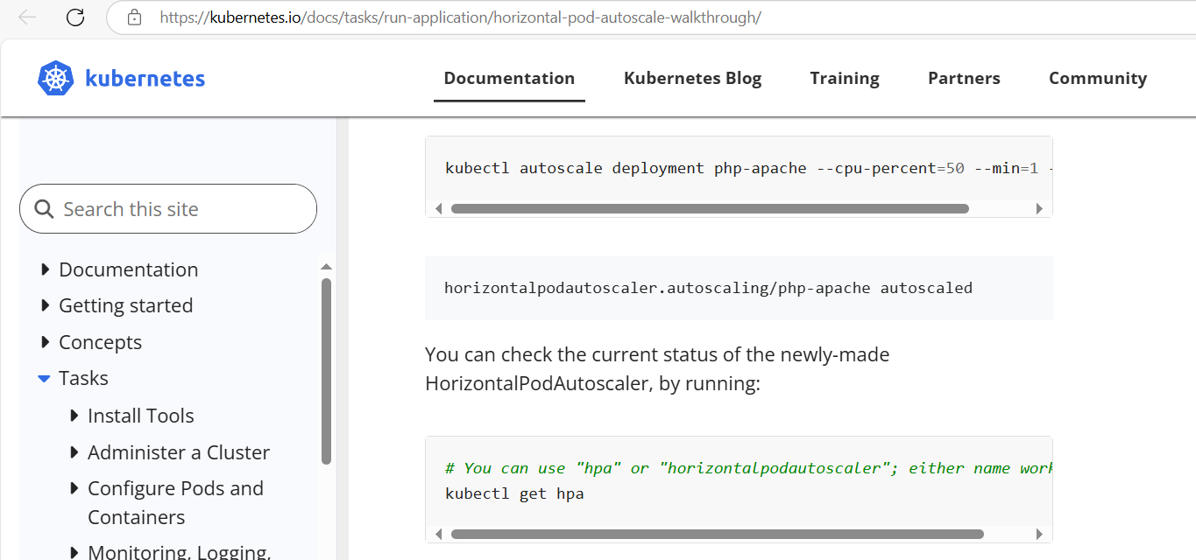

controlplane:~$ kubectl autoscale deployment apache-server -n auto-scale --cpu-percent=50 --min=1 --max=4
horizontalpodautoscaler.autoscaling/apache-server autoscaled
horizontalpodautoscaler.autoscaling/apache-server edited
edit the autoscale created with below value under spec.

behavior:
scaleDown:
stabilizationWindowSeconds: 60

controlplane:~$ kubectl get horizontalpodautoscalers.autoscaling -n auto-scale
NAME REFERENCE TARGETS MINPODS MAXPODS REPLICAS AGE
apache-server Deployment/apache-server cpu: <unknown>/50% 1 4 1 2m14s
controlplane:~$ kubectl get horizontalpodautoscalers.autoscaling -n auto-scale -o yaml > hpa1.yaml

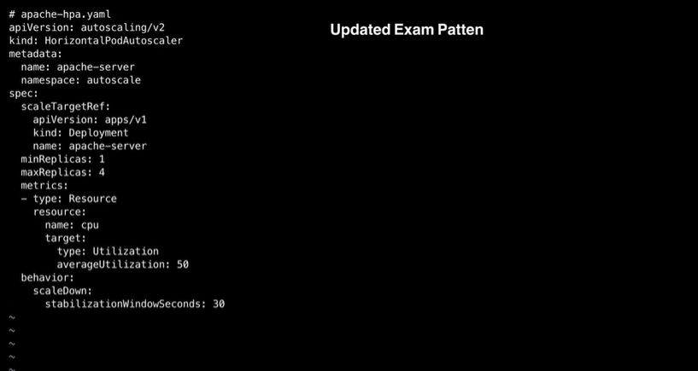
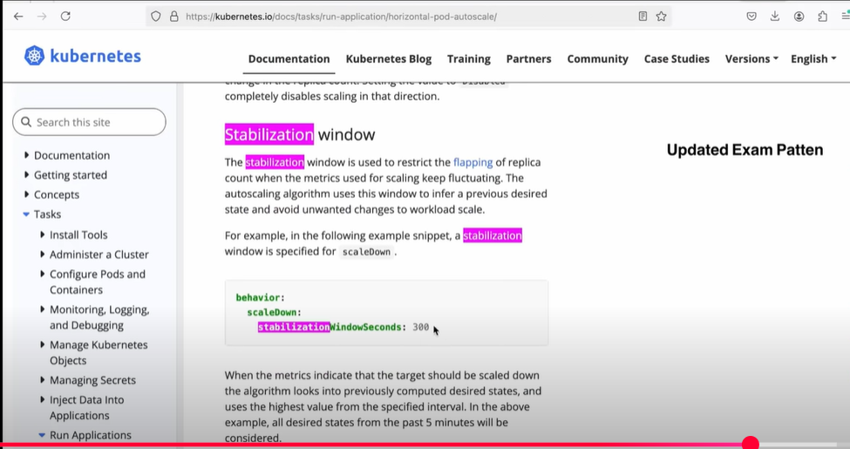

Example Code where stablisation fits:

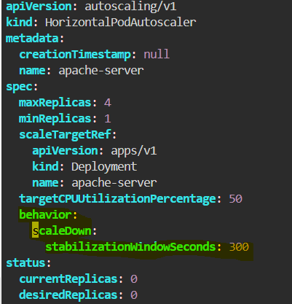

Question No: 2 (Weightage: 10%)
- Reconfigure the existing deployment front-end in namespace spline-reticulator to expose port 80/tcp of the existing container nginx.
- Create a new service named front-end-svc exposing the container port 80/tcp.
- Configure the new service to also expose the individual pod via a NodePort.

Edit the deployment yaml to add the continer port
controlplane:~$ kubectl create deployment front-end -n spline-reticulator --image=nginx --port=80 --dry-run=client -o yaml > depl.yaml
controlplane:~$ kubectl create ns spline-reticulator
namespace/spline-reticulator created
controlplane:~$ kubectl apply -f depl.yaml
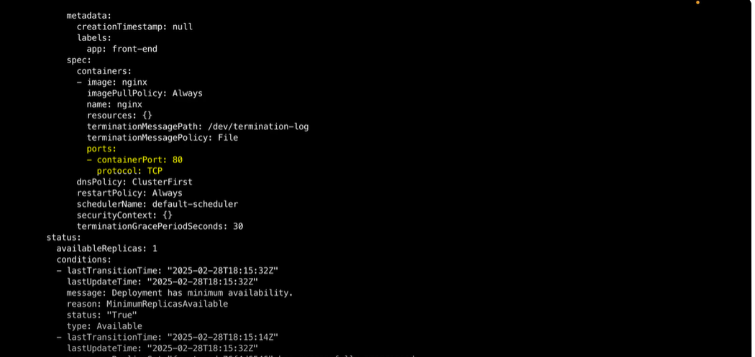

ports:
- containerPort: 80
protocol: TCP
We can do it Imperratively aswell using below command:
kubectl set container-port deployment/front-end nginx=80 -n spline-reticultor

Key word nodeport to create the service:
Service | Kubernetes - https://kubernetes.io/docs/concepts/services-networking/service/
find the node port section:
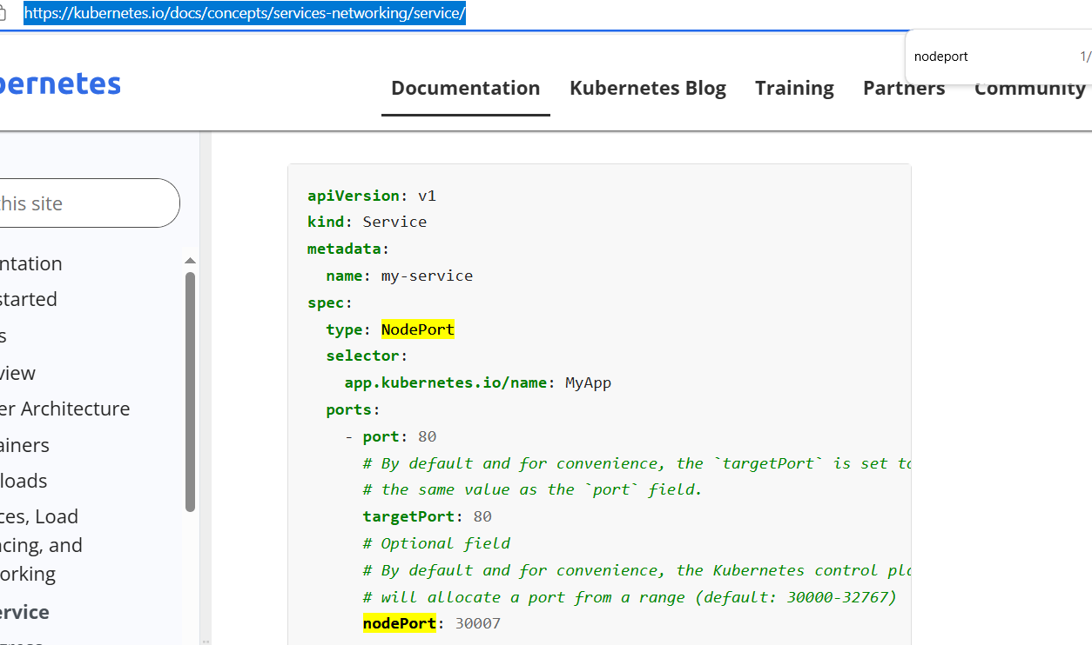

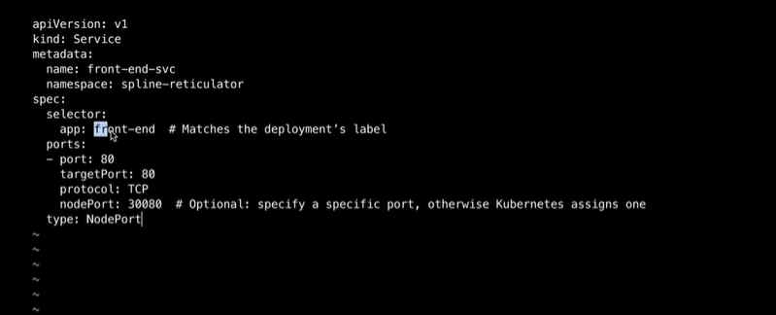

apiVersion: v1
kind: Service
metadata:
name: front-end-svc
namespace: spline-reticulator
spec:
type: NodePort
selector:
app: front-end
ports:
- port: 80
# By default and for convenience, the `targetPort` is set to
# the same value as the `port` field.
targetPort: 80
# Optional field
# By default and for convenience, the Kubernetes control plane
# will allocate a port from a range (default: 30000-32767)
nodePort: 30007

controlplane:~$ kubectl create service nodeport front-end-svc --tcp 80 --dry-run=client -o yaml > svc.yaml

controlplane:~$ cat svc.yaml
apiVersion: v1
kind: Service
metadata:
creationTimestamp: null
labels:
app: front-end-svc
name: front-end-svc
spec:
ports:
- name: "80"
port: 80
protocol: TCP
targetPort: 80
selector:
app: front-end
type: NodePort
status:
loadBalancer: {}

controlplane:~$ vi svc.yaml

apiVersion: v1
kind: Service
metadata:
creationTimestamp: null
labels:
app: front-end-svc
name: front-end-svc
namespace: spline-reticulator
spec:
ports:
- name: "80"
port: 80
protocol: TCP
targetPort: 80
nodePort: 30080
selector:
app: front-end
type: NodePort
status:
loadBalancer: {}

Question No: 3 (Weightage: 15%)
- Update the existing deployment synergy-leverager, adding a co-located container named sidecar using the busybox:stable image to the existing pod.
- The new co-located container has to run the following command:
/bin/sh -c "tail -n+1 -f /var/log/synergy-leverager.log"
Use a volume mounted at /var/log to make the log file synergy-leverager.log available to the co-located container.

Deployment first: apply this deployment:

https://kubernetes.io/docs/concepts/workloads/pods/sidecar-containers/

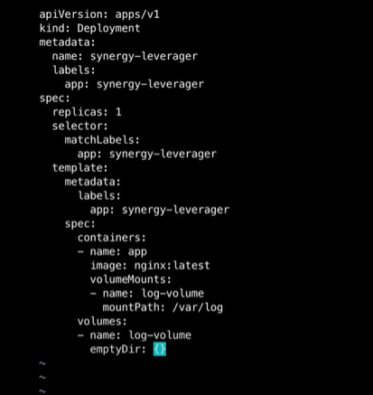

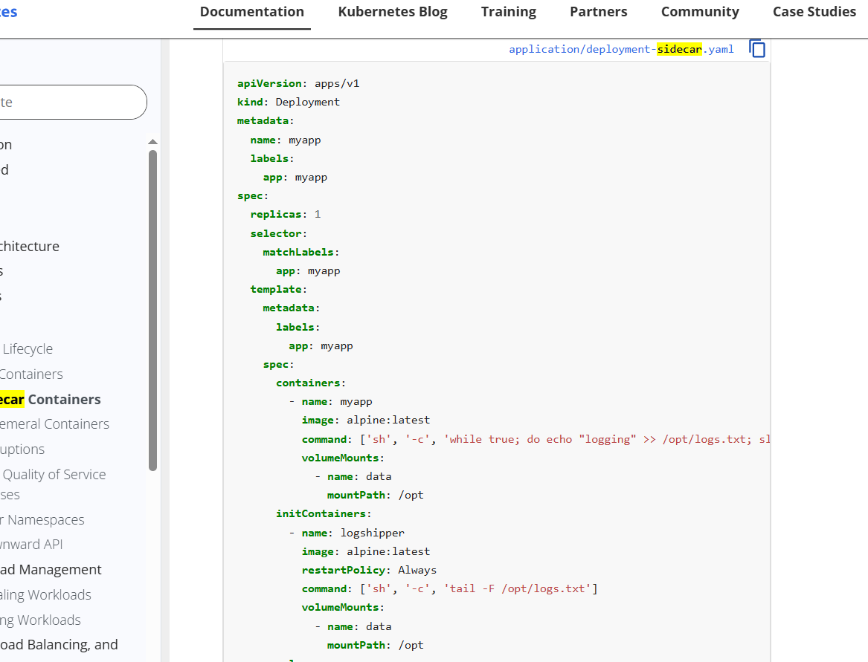

controlplane:~$ cat sidecar.yaml
apiVersion: apps/v1
kind: Deployment
metadata:
name: synergy-leverager
labels:
app: synergy-leverager
spec:
replicas: 1
selector:
matchLabels:
app: synergy-leverager
template:
metadata:
labels:
app: synergy-leverager
spec:
containers:
- name: synergy-leverager
image: alpine:latest
command: ['/bin/sh', '-c', 'while true; do echo "logging" >> /var/log/synergy-leverager.log; sleep 1; done']
volumeMounts:
- name: data
mountPath: /var/log
- name: sidecar
image: busybox:stable
command: ['/bin/sh', '-c', 'tail -n+1 -f /var/log/synergy-leverager.log']
volumeMounts:
- name: data
mountPath: /var/log
volumes:
- name: data
emptyDir: {}

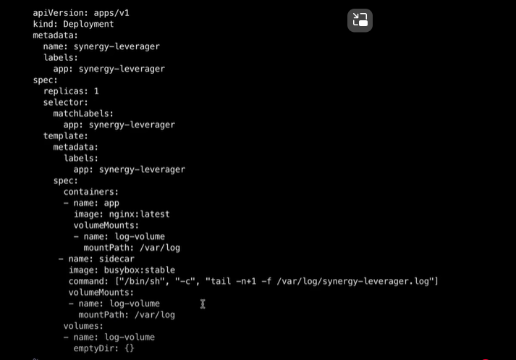

To verify this get in to the pod using below command :
kubectl exec -it <pod-name> -c synergy-leverager – sh
cat /var/log/synergy-leverager.log

Question No: 4 (Weightage: 11%)
Perform the following tasks:
Create a new Priority Class named high-priority for user workloads, with a value one less than the highest existing user-defined priority class value.
Patch the existing busybox-logger Deployment in the priority namespace to use the high-priority class.
Note — Pods from other Deployments in the priority namespace should be evicted.

Make sure you evicted the pods form the other deployment in the name space priority are evicted

ANS:
Key word: Priority class
controlplane:~$ kubectl create ns priority
namespace/priority created
controlplane:~$ kubectl create deployment -n priority busybox-logger --image=busybox:stable
deployment.apps/busybox-logger created

consider below priority class is already available:
controlplane:~$ kubectl create priorityclass existing-priority --value=1000 --description="this is exiting class"
Above is to create the deployment which is already there.

Till above we have done all the things that is already avaialable

As part of the question we are creating the below

Keyword : Kubectl patch deployment
kubectl patch | Kubernetes - https://kubernetes.io/docs/reference/kubectl/generated/kubectl_patch/

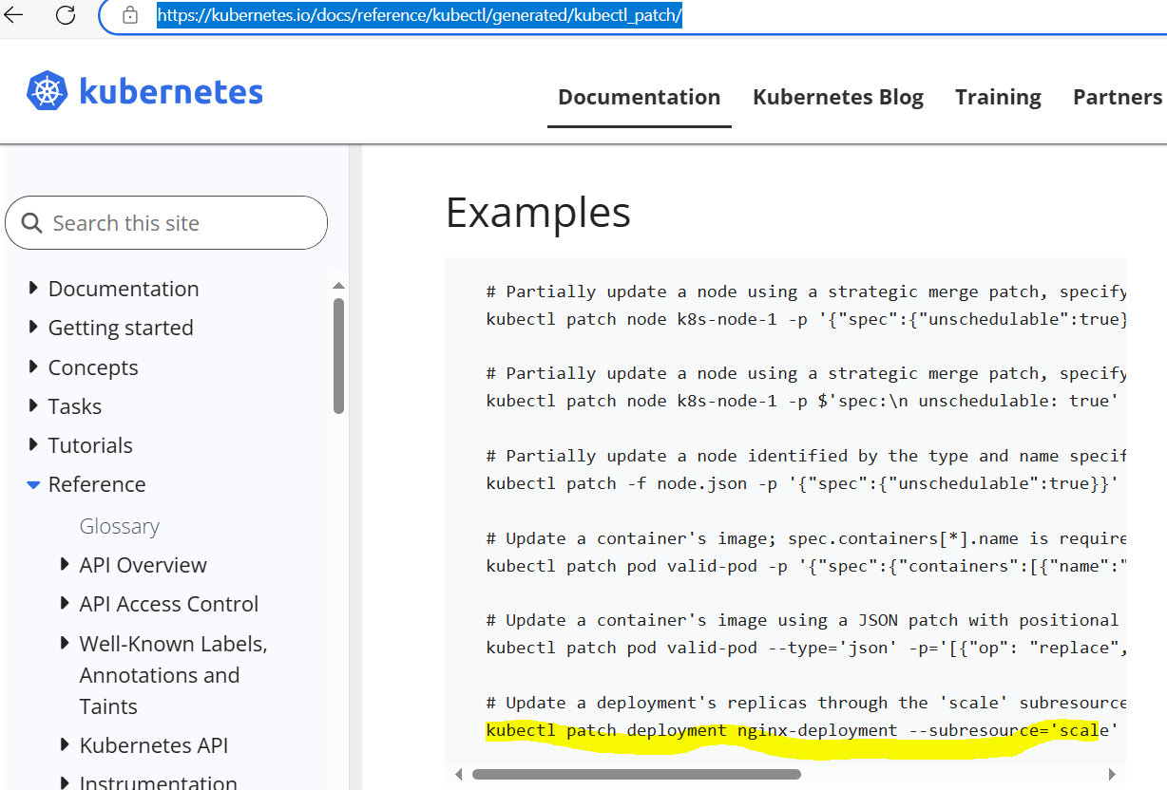

Patch the deployment to use the new priority class create .

controlplane:~$ kubectl create ns priority
namespace/priority created

Pre-req:
controlplane:~$ cat existingpriorityclass.yaml
apiVersion: scheduling.k8s.io/v1
kind: PriorityClass
metadata:
name: high-priority-existing
value: 1000
preemptionPolicy: Never
globalDefault: false
description: "This priority class will not cause other pods to be preempted."
controlplane:~$

HighPriority class:
controlplane:~$ cat highpriorityclass.yaml
apiVersion: scheduling.k8s.io/v1
kind: PriorityClass
metadata:
name: high-priority
value: 999
preemptionPolicy: PreemptLowerPriority
globalDefault: false
description: "This priority class will not cause other pods to be preempted."
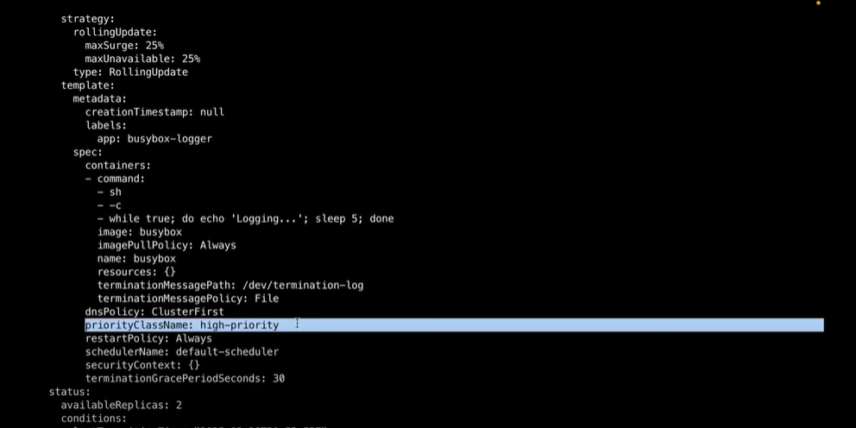
controlplane:~$ kubectl create deployment -n priority busybox-logger --image=busybox:stable
deployment.apps/busybox-logger created

kubectl patch deployment busybox-logger -n priority --type='merge' -p '{"spec": {"template": {"spec": {"priorityClassName": "high-priority"}}}}'

controlplane:~$ kubectl edit deployments.apps -n priority busybox-logger
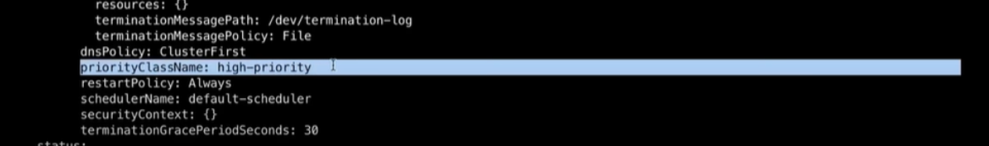

Question No: 5 (Weightage: 8%)
First, create a new StorageClass named local-path for an existing provisioner named rancher.io/local-path. Set the volume binding mode to WaitForFirstConsumer.
Note - Not setting the volume binding mode or setting it to anything other than WaitForFirstConsumer may result in reduced score. Next, configure the StorageClass local-path as the default StorageClass.
Note - Do not modify any existing Deployments or PersistentVolumeClaims. Failure to do so may result in a reduced score.
Key word : Storage Classes
Storage Classes | Kubernetes
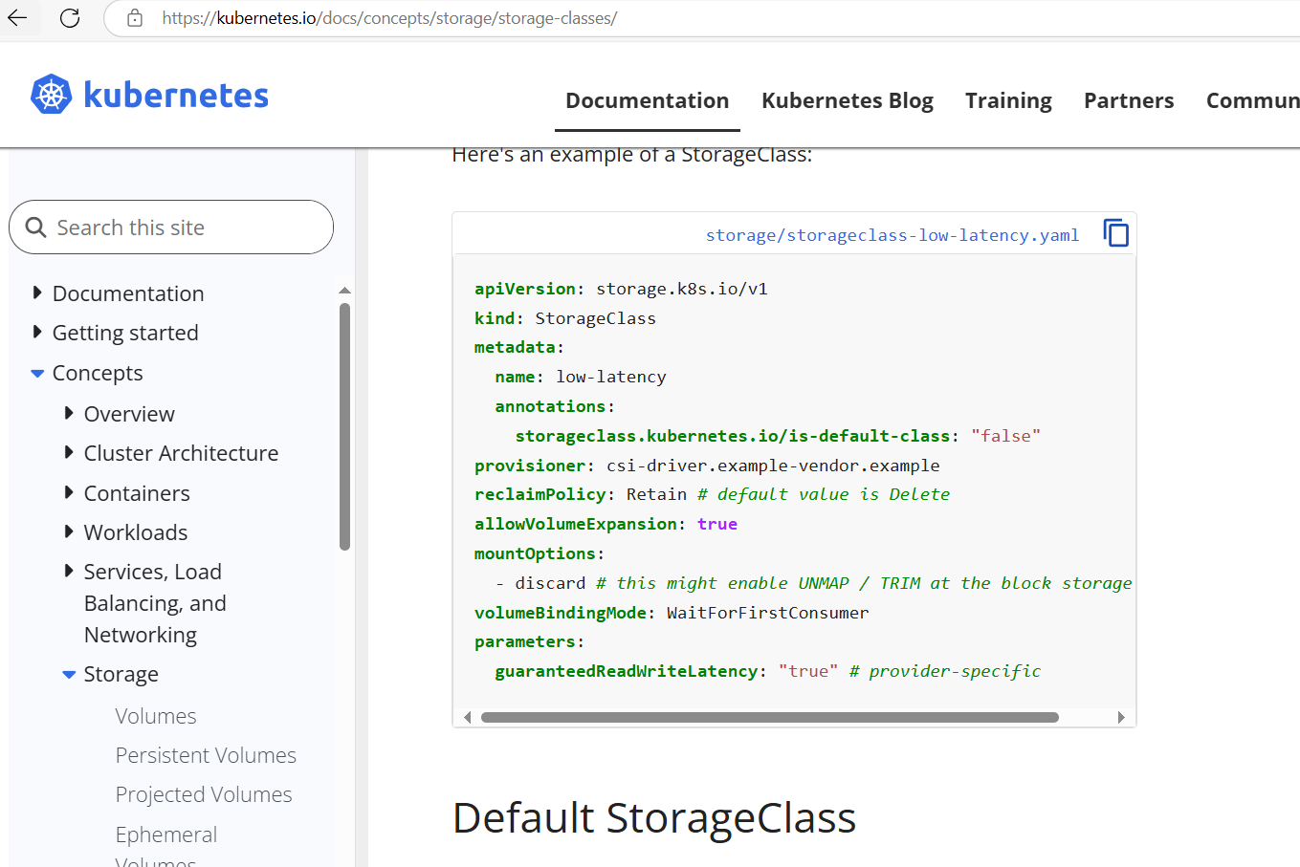

apiVersion: storage.k8s.io/v1
kind: StorageClass
metadata:
name: local-path
annotations:
storageclass.kubernetes.io/is-default-class: "true"
provisioner: rancher.io/local-path
volumeBindingMode: WaitForFirstConsumer

Question No: 6 (Weightage: 7%)
Install ArgoCD in the cluster:
Add the official Argo CD Helm repository with the name argo.
Generate a template of the ArgoCD Helm Chart version 7.7.3 for the argocd namespace, save to ~/argo-helm.yaml.
Configure the chart not to install CRDs.
Note — Argo CD CRDs already pre-installed.

CRD is installed in the exam already in our practise do it manually using below :

controlplane:~$ kubectl create ns argocd
namespace/argocd created
controlplane:~$ kubectl apply -n argocd -f https://raw.githubusercontent.com/argoproj/argo-cd/stable/manifests/install.yaml

controlplane:~$ kubectl get crd | grep argo
applications.argoproj.io 2025-04-18T17:24:05Z
applicationsets.argoproj.io 2025-04-18T17:24:05Z
appprojects.argoproj.io 2025-04-18T17:24:06Z
controlplane:~$

If you don’t have the helm install it using below :
curl https://raw.githubusercontent.com/helm/helm/main/scripts/get-helm-3 | bash
And Add the repo:
controlplane:~$ helm repo add argo https://argoproj.github.io/argo-helm
"argo" has been added to your repositories
helm repo add stable https://charts.helm.sh/stable
helm repo update

Below is for the argo repo to be added to install it .
controlplane:~$ helm repo update
Hang tight while we grab the latest from your chart repositories...
...Successfully got an update from the "argo" chart repository
...Successfully got an update from the "stable" chart repository
Update Complete. ⎈Happy Helming!⎈
controlplane:~$ helm repo list
NAME URL
argo https://argoproj.github.io/argo-helm
stable https://charts.helm.sh/stable
controlplane:~$
Helm template command will help to write the yaml file with out applying on it. As per question save the yaml in the correct path and name space mention is argo make sure you passed it in the helm command and cat the yaml once created and you can see the namespace.

listing the repo list we can see the argo repo in it

helm template argocd argo/argo-cd --version 7.7.3 --namespace argocd --set crds.install=false > ~/argo-helm.yaml

k apply -f argo-helm.yaml

controlplane:~$ ls -ltr
total 100
lrwxrwxrwx 1 root root 1 Mar 22 08:03 filesystem -> /
-rw-r--r-- 1 root root 222 Apr 17 14:40 str.yaml
-rw-r--r-- 1 root root 96769 Apr 17 15:28 argo-helm.yaml

Question No: 7 (Weightage: 13%)
A MariaDB Deployment in the mariadb namespace has been deleted. Restore it ensuring data persistence:
Create a PVC named mariadb in the mariadb namespace: Storage 250Mi.
Note — Use the existing retained PersistentVolume.
Edit the mariadb-deployment.yaml to use the new PVC.
Apply the updated Deployment to the cluster.
In exam mariadb namespace is already there .
Pv is already there
so create those for our practise we need to create in our lab.

Kubectl create namespace mariadb

Create persistant volume by refering the pv in documentation
apiVersion: v1
kind: PersistentVolume
metadata:
name: mariadb-pv
spec:
capacity:
storage: 250Mi
accessModes:
- ReadWriteOnce
persistentVolumeReclaimPolicy: Retain
storageClassName: standard
hostPath:
path: /tmp/mariadb

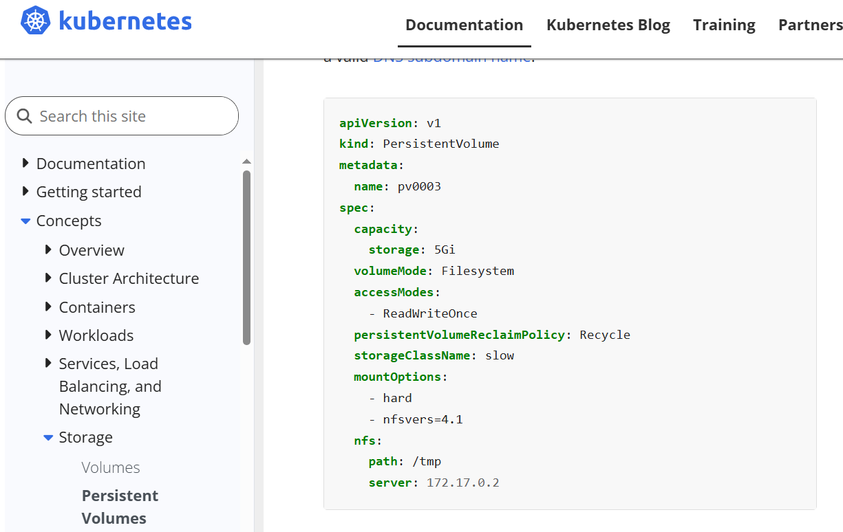
Once you created the PV yaml apply it using the kubectl apply -f *yaml

Now create the persistent volume claim using the documentation this is requested in the question as well.

PVC:

apiVersion: v1
kind: PersistentVolumeClaim
metadata:
name: mariadb
namespace: mariadb
spec:
accessModes:
- ReadWriteOnce
storageClassName: standard
resources:
requests:
storage: 250Mi

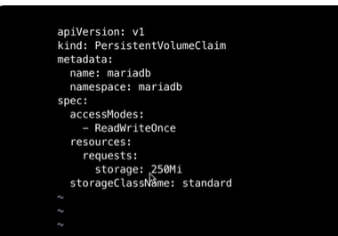

Under persistant volume we can see the pvc yaml as well edit it as per the requirement.

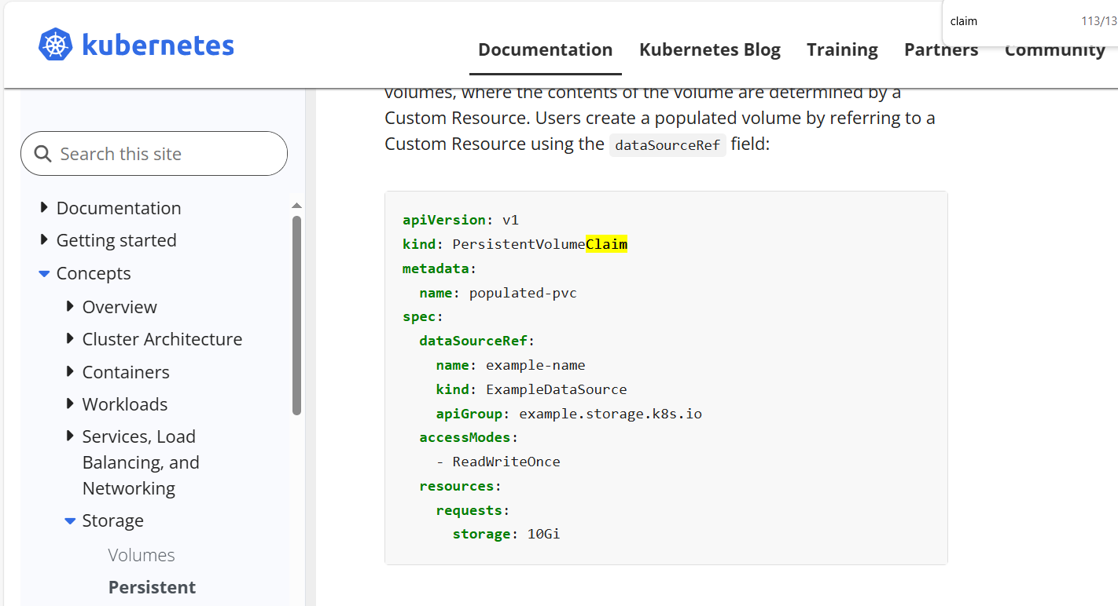
Above is the doc page

create the deployment :

controlplane:~$ cat dep1.yaml
apiVersion: apps/v1
kind: Deployment
metadata:
name: mariadb
namespace: mariadb
spec:
replicas: 1
selector:
matchLabels:
app: mariadb
template:
metadata:
labels:
app: mariadb
spec:
containers:
- name: mariadb
image: mariadb:10.5
env:
- name: MYSQL_ROOT_PASSWORD
value: rootpassword
ports:
- containerPort: 3306
volumeMounts:
- name: mariadb-storage
mountPath: /var/lib/mysql
volumes:
- name: mariadb-storage
persistentVolumeClaim:
claimName: mariadb

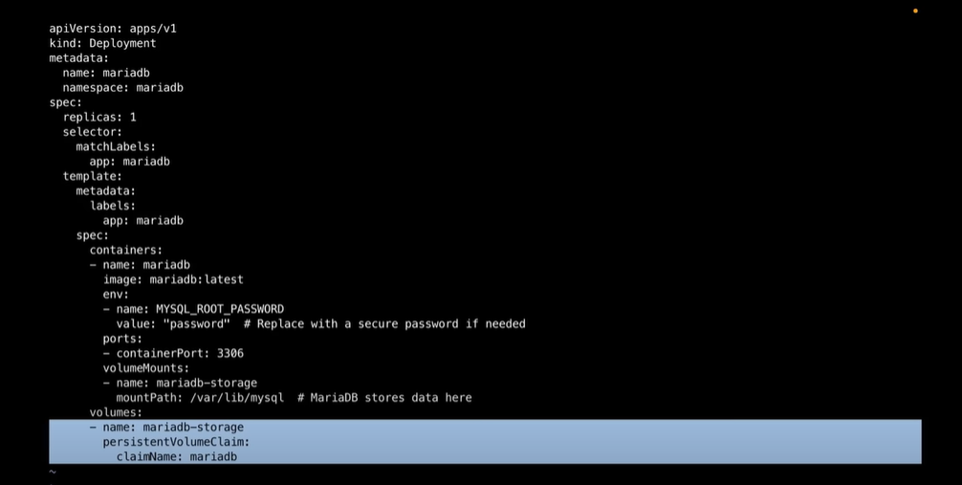
we can see the above the mariadb-storage is added in the deployment.
Kubectl get deployment -n mariadb
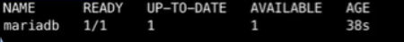

kubectl get pvc -n mariadb
kubectl describe deployments.apps -n mariadb mariadb

Question No: 8 (Weightage: 12%)
Migrate an existing web application from Ingress to Gateway API. Maintain HTTPS access.
Create a Gateway named web-gateway with hostname gateway.web.k8s.local (existing TLS and listener configuration).
Create an HTTPRoute named web-route with hostname gateway.web.k8s.local (maintain existing routing rules).
Note — GatewayClass nginx is installed.

This is the pre-requisites in the exam already it will be installed :
gateway class is present in exam , ingress will be already present, existing web application will be already present.

controlplane:~$ kubectl apply -f https://github.com/kubernetes-sigs/gateway-api/releases/download/v1.1.0/standard-install.yaml
customresourcedefinition.apiextensions.k8s.io/gatewayclasses.gateway.networking.k8s.io created

customresourcedefinition.apiextensions.k8s.io/gateways.gateway.networking.k8s.io created
customresourcedefinition.apiextensions.k8s.io/grpcroutes.gateway.networking.k8s.io created
customresourcedefinition.apiextensions.k8s.io/httproutes.gateway.networking.k8s.io created
customresourcedefinition.apiextensions.k8s.io/referencegrants.gateway.networking.k8s.io created

controlplane:~$
controlplane:~$ kubectl apply -f https://raw.githubusercontent.com/nginxinc/nginx-gateway-fabric/v1.6.2/deploy/crds.yaml
customresourcedefinition.apiextensions.k8s.io/clientsettingspolicies.gateway.nginx.org created
customresourcedefinition.apiextensions.k8s.io/nginxgateways.gateway.nginx.org created
customresourcedefinition.apiextensions.k8s.io/nginxproxies.gateway.nginx.org created
customresourcedefinition.apiextensions.k8s.io/observabilitypolicies.gateway.nginx.org created
customresourcedefinition.apiextensions.k8s.io/snippetsfilters.gateway.nginx.org created
customresourcedefinition.apiextensions.k8s.io/upstreamsettingspolicies.gateway.nginx.org created

controlplane:~$ kubectl get gatewayclass
No resources found

controlplane:~$ kubectl apply -f https://raw.githubusercontent.com/nginxinc/nginx-gateway-fabric/v1.6.2/deploy/default/deploy.yaml
namespace/nginx-gateway created
serviceaccount/nginx-gateway created
clusterrole.rbac.authorization.k8s.io/nginx-gateway created
clusterrolebinding.rbac.authorization.k8s.io/nginx-gateway created
configmap/nginx-includes-bootstrap created
service/nginx-gateway created
deployment.apps/nginx-gateway created
gatewayclass.gateway.networking.k8s.io/nginx created
nginxgateway.gateway.nginx.org/nginx-gateway-config created

controlplane:~$ kubectl get gatewayclass
NAME CONTROLLER ACCEPTED AGE
nginx gateway.nginx.org/nginx-gateway-controller Unknown 11s
controlplane:~$

controlplane:~$ kubectl get pods -n nginx-gateway
NAME READY STATUS RESTARTS AGE
nginx-gateway-84ff794cd-529cp 0/2 PodInitializing 0 11s

kubectl get svc -n nginx-gateway
NAME TYPE CLUSTER-IP EXTERNAL-IP PORT(S) AGE
nginx-gateway LoadBalancer 10.102.174.91 <pending> 80:31106/TCP,443:30519/TCP 12s

If below gateway class is not present then create, in exam it will be already present:.
---
apiVersion: gateway.networking.k8s.io/v1
kind: GatewayClass
metadata:
name: nginx
spec:
controllerName: “gateway.nginx.org/gateway-controller”

kubectl get gatewayclass
NAME CONTROLLER ACCEPTED AGE
nginx gateway.nginx.org/nginx-gateway-controller Unknown 11s

You should see:
- A nginx-gateway deployment
- GatewayClass: nginx

Install ingress , in exam these will be already present:
kubectl apply -f https://raw.githubusercontent.com/kubernetes/ingress-nginx/controller-v1.10.1/deploy/static/provider/cloud/deploy.yaml

kubectl get svc -n ingress-nginx

echo "127.0.0.1 gateway.web.k8s.local" | sudo tee -a /etc/hosts

apiVersion: networking.k8s.io/v1
kind: Ingress
metadata:
name: web
annotations:
nginx.ingress.kubernetes.io/rewrite-target: /
spec:
tls:
- hosts:
- gateway.web.k8s.local
secretName: web-tls
rules:
- host: gateway.web.k8s.local
http:
paths:
- path: /
pathType: Prefix
backend:
service:
name: web-service
port:
number: 80

kubectl get pods -n ingress-nginx
kubectl get svc -n ingress-nginx
kubectl logs -n ingress-nginx -l app.kubernetes.io/name=ingress-nginx

# webapp.yaml
apiVersion: v1
kind: Namespace
metadata:
name: webapp

---
apiVersion: apps/v1
kind: Deployment
metadata:
name: web
namespace: webapp
spec:
replicas: 2
selector:
matchLabels:
app: web
template:
metadata:
labels:
app: web
spec:
containers:
- name: web
image: nginx
ports:
- containerPort: 80

kubectl get pods -n webapp -o wide
kubectl logs -l app=web -n webapp

---
apiVersion: v1
kind: Service
metadata:
name: web-service
namespace: webapp
spec:
selector:
app: web
ports:
- port: 80
targetPort: 80

curl http://gateway.web.k8s.local # now you will see the ingress routing the traffic to webserver.

In exam below Ssl and secret will be there in the exam for our scenario im creating it using the openssl.
Create the TLS Secret (HTTP):

openssl req -x509 -nodes -days 365 -newkey rsa:2048 \
-subj "/CN=gateway.web.k8s.local" \
-keyout tls.key -out tls.crt

controlplane:~$ ls -ltr
total 24
lrwxrwxrwx 1 root root 1 Mar 22 08:03 filesystem -> /
-rw-r--r-- 1 root root 157 Apr 22 05:42 gatewayclass.yaml
-rw-r--r-- 1 root root 386 Apr 22 05:46 dep.yaml
-rw-r--r-- 1 root root 157 Apr 22 05:47 ser.yaml
-rw-r--r-- 1 root root 432 Apr 22 05:50 ingress.yaml
-rw------- 1 root root 1704 Apr 22 05:50 tls.key
-rw-r--r-- 1 root root 1147 Apr 22 05:50 tls.crt

openssl req -x509 -nodes -days 365 -newkey rsa:2048 \
-subj "/CN=webapp.local" \
-keyout tls.key -out tls.crt

controlplane:~$ kubectl create secret tls web-tls \
--cert=tls.crt --key=tls.key \
-n webapp
secret/web-tls created
controlplane:~$

use Key word gateway api in the documentation page to get the gateway api yaml.

Gateway API | Kubernetes

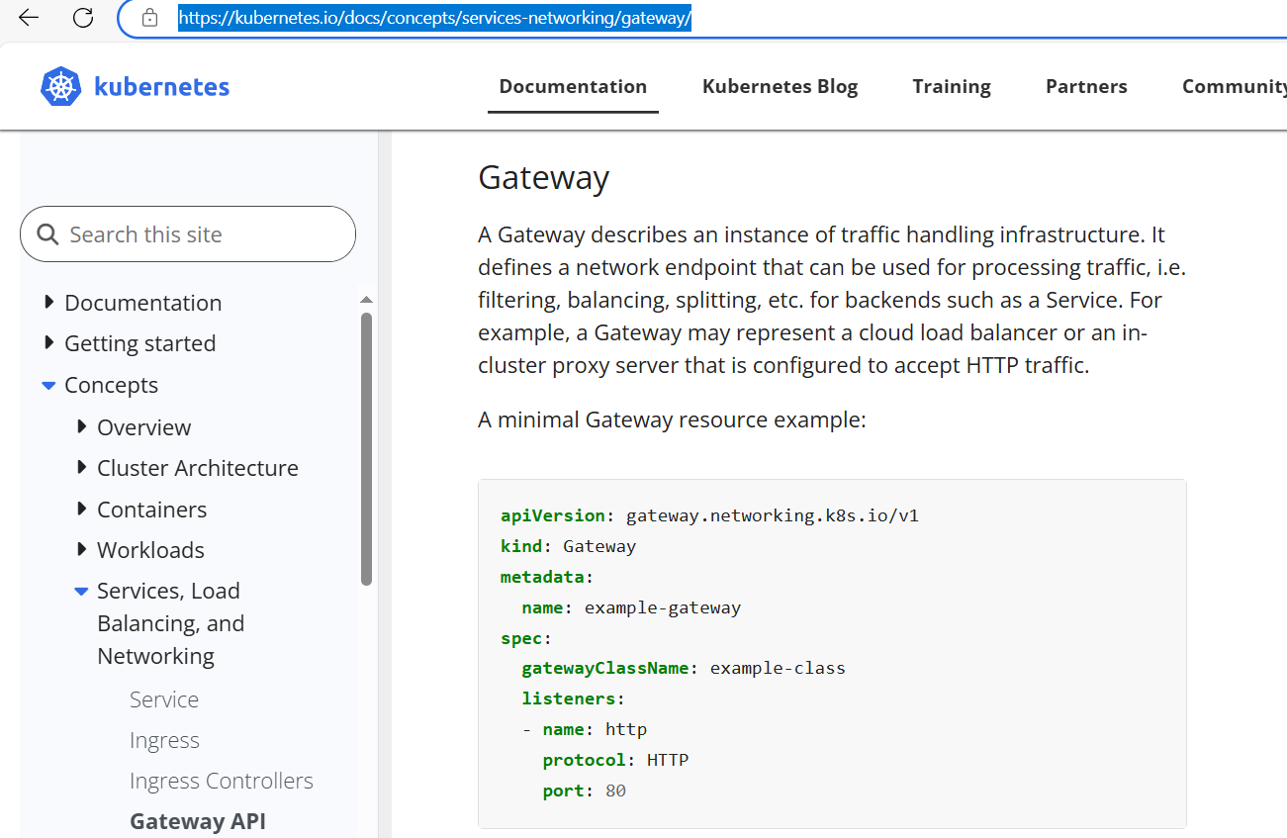
Migrating from Ingress - Kubernetes Gateway API

Create the webgateway and HTTProute:
# gateway.yaml
apiVersion: gateway.networking.k8s.io/v1
kind: Gateway
metadata:
name: web-gateway
namespace: webapp
spec:
gatewayClassName: nginx
listeners:
- name: https
protocol: HTTPS
port: 443
hostname: gateway.web.k8s.local
tls:
mode: Terminate
certificateRefs:
- kind: Secret
name: web-tls
- name: http
protocol: HTTP
port: 80
hostname: gateway.web.k8s.local

controlplane:~$ kubectl get svc -n webapp
NAME TYPE CLUSTER-IP EXTERNAL-IP PORT(S) AGE
web-service ClusterIP 10.96.222.53 <none> 80/TCP 41m

controlplane:~$ kubectl get svc -n nginx-gateway
NAME TYPE CLUSTER-IP EXTERNAL-IP PORT(S) AGE
nginx-gateway LoadBalancer 10.102.97.45 <pending> 80:32205/TCP,443:30441/TCP 54m
controlplane:~$

Create HTTP route:

---
apiVersion: gateway.networking.k8s.io/v1
kind: HTTPRoute
metadata:
name: web-route
namespace: webapp
spec:
parentRefs:
- name: web-gateway
hostnames:
- gateway.web.k8s.local
rules:
- matches:
- path:
type: PathPrefix
value: /
backendRefs:
- name: web-service
port: 80

kubectl get svc web-service -n webapp -o yaml

kubectl get gateway web-gateway -n webapp -o yaml
kubectl get httproute web-route -n webapp -o yaml

kubectl logs -n nginx-gateway -l app.kubernetes.io/component=gateway

test with the port forwarding :
kubectl port-forward -n nginx-gateway svc/nginx-gateway 8443:443

controlplane:~$ curl -k https://gateway.web.k8s.local:30441
<!DOCTYPE html>
<html>
<head>
<title>Welcome to nginx!</title>
<style>
html { color-scheme: light dark; }
body { width: 35em; margin: 0 auto;
font-family: Tahoma, Verdana, Arial, sans-serif; }
</style>
</head>
<body>
<h1>Welcome to nginx!</h1>
<p>If you see this page, the nginx web server is successfully installed and
working. Further configuration is required.</p>

<p>For online documentation and support please refer to
<a href="http://nginx.org/">nginx.org</a>.<br/>
Commercial support is available at
<a href="http://nginx.com/">nginx.com</a>.</p>

<p><em>Thank you for using nginx.</em></p>
</body>
</html>

Question No: 9 (Weightage: 10%)
Install and set up a Container Network Interface (CNI) that meets these requirements: pick and install one of the CNI options:

the CNI you choose must statisfy the following requirement:
<native network policy support>
Pick and install one of the CNI options:
Flannel version 0.26.1 Manifest — https://github.com/flannel-io/flannel/releases/download/v0.26.1/kube-flanner.yml
Calico version 3.28.2 Manifest —https://raw.githubusercontent.com/projectcalico/calico/v3.28.2/manifests/tigera-operator.yaml

k apply -f https://raw.githubusercontent.com/projectcalico/calico/v3.28.2/manifests/tigera-operator.yaml

We have to install the CNI as per the question requirement, they give multiple CNI we need to choose one from that.

We can go through the CNI yaml file and check the all requirement mentioned in the yaml file or not.

We can achive in our lab using the kind cluster . Use below config yaml to initiate the kind cluster .

kubectl create -f https://raw.githubusercontent.com/projectcalico/calico/v3.28.0/manifests/calico.yaml

Below kind config will initiate the cluster with out CNI , one control plane and worker.

controlplane:~$ curl -O https://raw.githubusercontent.com/projectcalico/calico/v3.28.2/manifests/tigera-operator.yaml^C
controlplane:~$ ls -ltr
total 1728
lrwxrwxrwx 1 root root 1 Mar 22 08:03 filesystem -> /
-rw-r--r-- 1 root root 1765780 Apr 22 06:39 tigera-operator.yaml
controlplane:~$

in exam select the calico as calico has more network policies.

Question No: 10 (Weightage: 9%)
You manage a WordPress application. Some pods not up and running. Adjust all Pod resource requests:
Divide node resources evenly across 3 pods.
Give each pod fair share of CPU and memory.
Add overhead to keep node stable.
Use exact same requests for both containers and init containers.
Scale down WordPress deployment to 0 replicas while updating resource requests.
After updates:
WordPress keeps 3 replicas.
All pods are running and ready.

the requirement is to allocate the resources eventually for all the pods to work.

This wordpress will be already there so no need to create yaml in exam, for practise create one.
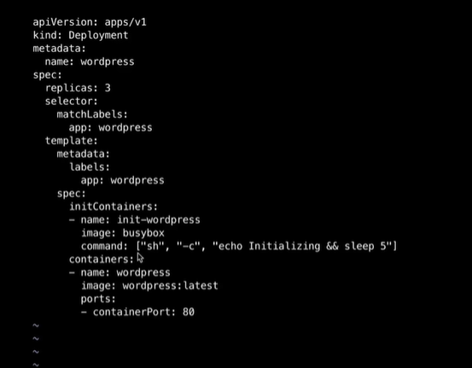

apiVersion: apps/v1
kind: Deployment
metadata:
name: wordpress
labels:
app.kubernetes.io/name: wordpress
spec:
replicas: 3
selector:
matchLabels:
app.kubernetes.io/name: wordpress
template:
metadata:
labels:
app.kubernetes.io/name: wordpress
spec:
initContainers:
- name: init-wordpress
image: busybox:1.28
command: ['sh', '-c', "echo initializing wordpress..."]
containers:
- name: wordpress
image: busybox:1.28
command: ['sh', '-c', 'echo WordPress is running! && sleep 3600']

Kubectl scale deployment wordpress –replicas=0

After adding the resource :

apiVersion: apps/v1
kind: Deployment
metadata:
name: wordpress
labels:
app.kubernetes.io/name: wordpress
spec:
replicas: 3
selector:
matchLabels:
app.kubernetes.io/name: wordpress
template:
metadata:
labels:
app.kubernetes.io/name: wordpress
spec:
initContainers:
- name: init-wordpress
image: busybox:1.28
command: ['sh', '-c', "echo initializing wordpress..."]
resources:
requests:
cpu: "200m"
memory: "128Mi"
limits:
cpu: "300m"
memory: "192Mi"
containers:
- name: wordpress
image: busybox:1.28
command: ['sh', '-c', 'echo WordPress is running! && sleep 3600']
resources:
requests:
cpu: "200m"
memory: "128Mi"
limits:
cpu: "300m"
memory: "192Mi"

kubectl get deployments
kubectl get pods
kubectl rollout restart deployment <deployment name>

Make the changes in the request CPU: 100m , memory: 100Mi for the both the init and the main container.
Question No: 11 (Weightage: 10%)
Complete these tasks to prepare the system for Kubernetes: Set up cri-dockerd:
Install the Debian package: ~/cri-dockerd_0.3.9-3.0.ubuntu-focal_amd64.deb
Start the cri-dockerd service.
Enable and start the systemd service for cri-dockerd.
Configure these system parameters:
Set net.bridge.bridge-nf-call-iptables to 1.
Set net.ipv6.conf.all.forwarding to 1.
Set net.ipv4.ip_forward to 1.
commands :-
wget https://github.com/Mirantis/cri-dockerd/releases/download/v0.3.17/cri-dockerd_0.3.17.3-0.ubuntu-focal_amd64.deb
1. dpkg -i ~/cri-dockerd_0.3.17.3-0.ubuntu-focal_amd64.deb
2. controlplane:~$ sudo systemctl status cri-docker.socket
● cri-docker.socket - CRI Docker Socket for the API
Loaded: loaded (/usr/lib/systemd/system/cri-docker.socket; enabled; preset: enabled)
Active: active (running) since Sat 2025-05-17 16:09:07 UTC; 1min 27s ago
Triggers: ● cri-docker.service
Listen: /run/cri-dockerd.sock (Stream)
Tasks: 0 (limit: 2614)
Memory: 0B (peak: 256.0K)
CPU: 554us
CGroup: /system.slice/cri-docker.socket

May 17 16:09:07 controlplane systemd[1]: Starting cri-docker.socket - CRI Docker Socket for the API...
May 17 16:09:07 controlplane systemd[1]: Listening on cri-docker.socket - CRI Docker Socket for the API.
3. sudo systemctl enable cri-docker.socket
4. systemctl list-units | grep cri
in exam the package will be already available in the home directory , for our lab use the below to install .
wget https://github.com/Mirantis/cri-dockerd/releases/download/v0.3.1/cri-dockerd_0.3.1.3-0.ubuntu-jammy_amd64.deb

for every question we will have the documentation question available .
Set net.bridge.bridge-nf-call-iptables to 1
Set net.ipv6.conf.all.forwarding to 1
Set net.ipv4.ip_forward to 1

cat >>/etc/sysctl.d/kubernetes.conf<<EOF
net.bridge.bridge-nf-call-ip6tables = 1
net.bridge.bridge-nf-call-iptables = 1
net.ipv4.ip_forward = 1
EOF
sysctl --system

As per the documentation follow the file mentioned in the question and update it accordingly.

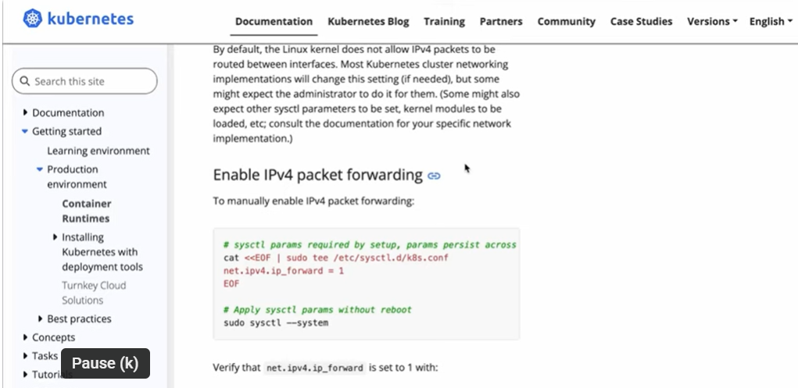
https://kubernetes.io/docs/setup/production-environment/tools/kubeadm/dual-stack-support/
# sysctl params required by setup, params persist across reboots
cat <<EOF | sudo tee -a /etc/sysctl.d/k8s.conf
net.ipv6.conf.all.forwarding = 1
EOF

# Apply sysctl params without reboot
sudo sysctl --system

Question No: 12 (Weightage: 7%)
List all custom CRDs from cert manager and store it in custom-crd.txt.
Get the subject field from the cert manager and store it in cert-manager-subject.txt.
in exam cert-manager-crd will be already installed , here in our lab we need to install manually to work on this question
kubectl apply -f https://github.com/cert-manager/cert-manager/releases/latest/download/cert-manager.crds.yaml
Commands:-
1.Install cert-manager CRD.
2.kubectl apply -f https://github.com/cert-manager/cert-...
3.kubectl get crd certificates.cert-manager.io -o jsonpath={.spec.versions[*].schema.openAPIV3Schema.properties.spec.properties.subject}
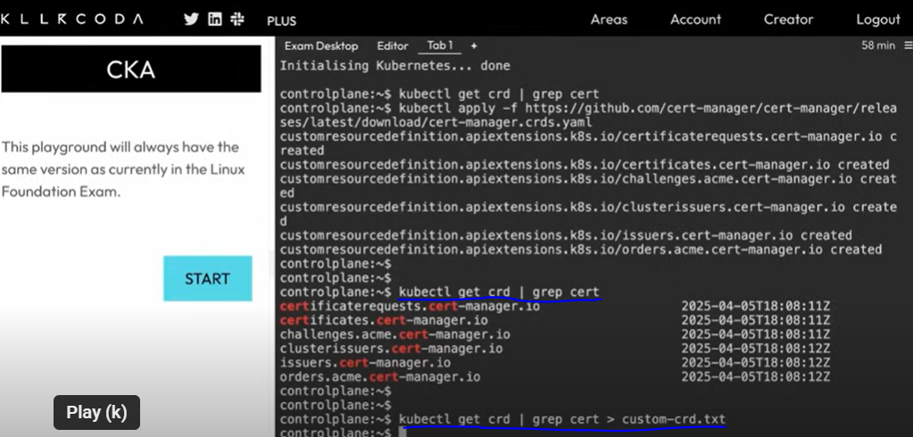
kubectl get crd | grep cert > custom-crd.txt
controlplane:~$ cat custom-crd.txt
certificaterequests.cert-manager.io 2025-04-17T17:46:07Z
certificates.cert-manager.io 2025-04-17T17:46:07Z
challenges.acme.cert-manager.io 2025-04-17T17:46:07Z
clusterissuers.cert-manager.io 2025-04-17T17:46:08Z
issuers.cert-manager.io 2025-04-17T17:46:08Z
orders.acme.cert-manager.io 2025-04-17T17:46:08Z
controlplane:~$
controlplane:~$ kubectl describe crd certificates.cert-manager.io
Name: certificates.cert-manager.io
Namespace:
Labels: app=cert-manager
app.kubernetes.io/instance=cert-manager
app.kubernetes.io/name=cert-manager
app.kubernetes.io/version=v1.17.1
Annotations: helm.sh/resource-policy: keep
API Version: apiextensions.k8s.io/v1
Kind: CustomResourceDefinition
Metadata:
Creation Timestamp: 2025-04-17T17:46:07Z
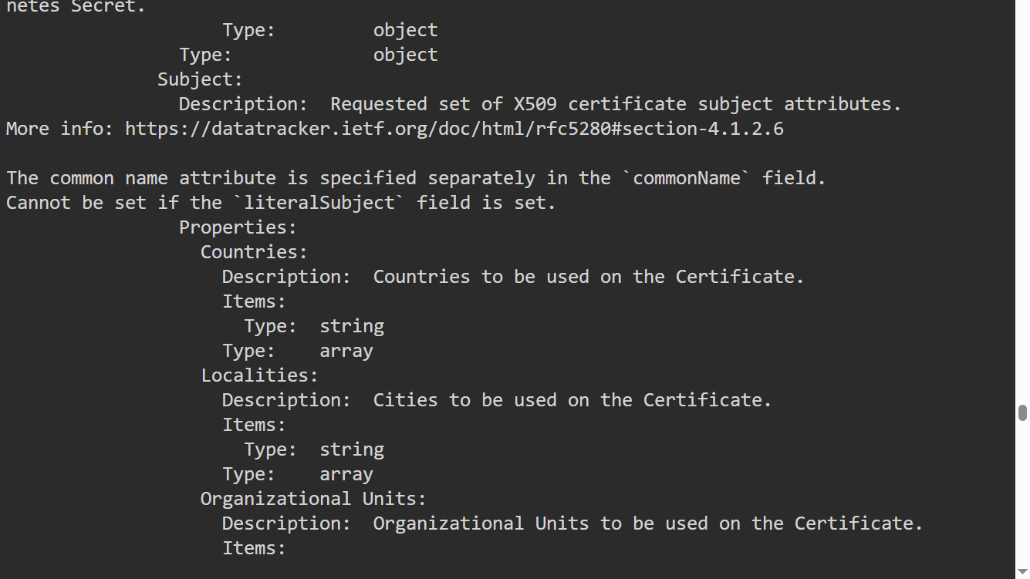
instead use this command to get those details :
kubectl get crd certificates.cert-manager.io -o jsonpath={.spec.versions[*].schema.openAPIV3Schema.properties.spec.properties.subject} > cert-manager-subject.txt
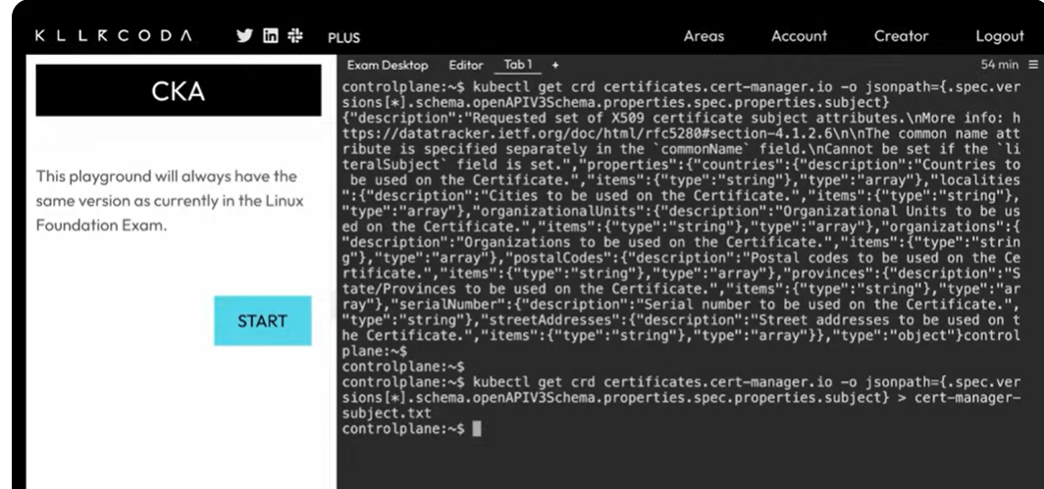

Question No: 13 (Weightage: 10%)
There are two deployments: frontend and backend deployment.
Frontend will be in frontend NS, backend in backend NS.
Apply the least permissive policy to have interaction between frontend and backend deployment.
Choose one of the 3 YAML files with the least permission:
YAML — pod selector of all, type is ingress, and pod selector with all
YAML — pod selector + namespace selector
YAML — pod selector, namespace selector, POD CIDR
3 YAML will be given we have to choose which opt for the requirement

: (Policy 3)
apiVersion: networking.k8s.io/v1
kind: NetworkPolicy
metadata:
name: frontend-to-backend-with-cidr
namespace: backend
spec:
podSelector:
matchLabels:
app: backend
policyTypes:
- Ingress
ingress:
- from:
- namespaceSelector:
matchLabels:
kubernetes.io/metadata.name: frontend
podSelector:
matchLabels:
app: frontend
ports:
- protocol: TCP
port: 8080
- from:
- ipBlock:
cidr: 192.168.1.0/24
ports:
- protocol: TCP
port: 8080

: (Policy 1)
apiVersion: networking.k8s.io/v1
kind: NetworkPolicy
metadata:
name: open-backend-access
namespace: backend
spec:
podSelector: {}
policyTypes:
- Ingress
ingress:
- from: []
ports:
- protocol: TCP
port: 8080

: (Policy 2)
apiVersion: networking.k8s.io/v1
kind: NetworkPolicy
metadata:
name: frontend-to-backend
namespace: backend
spec:
podSelector:
matchLabels:
app: backend
policyTypes:
- Ingress
ingress:
- from:
- namespaceSelector:
matchLabels:
kubernetes.io/metadata.name: frontend
podSelector:
matchLabels:
app: frontend
ports:
- protocol: TCP
port: 8080

Choose policy 2 as it is least and works in all the scenario.

Question 14:
Solve this question on: ssh cka5774
The CoreDNS configuration in the cluster needs to be updated:
Make a backup of the existing configuration Yaml and store it at /opt/course/16/coredns_backup.yaml.
You should be able to fast recover from the backup.
Update the CoreDNS configuration in the cluster so that DNS resolution for SERVICE.NAMESPACE.custom-domain will work exactly like and in addition to SERVICE.NAMESPACE.cluster.local.
Test your configuration for example from a Pod with busybox:1 image. These commands should result in an IP address:
nslookup kubernetes.default.svc.cluster.local
nslookup kubernetes.default.svc.custom-domain

Solution:
The CoreDNS configuration in the cluster needs to be updated:
Make a backup of the existing configuration YAML and store it at:
/opt/course/16/coredns_backup.yaml
Update the CoreDNS configuration so that DNS resolution for
SERVICE.NAMESPACE.custom-domain
works exactly like, and in addition to:
SERVICE.NAMESPACE.svc.cluster.local
Test using a pod with busybox:1 image:
These commands should both return an IP address:
nslookup kubernetes.default.svc.cluster.local
nslookup kubernetes.default.svc.custom-domain

Solution:
Step 1 — Backup CoreDNS ConfigMap
kubectl -n kube-system get configmap coredns -o yaml > /opt/course/16/coredns_backup.yaml
Step 2 — Edit CoreDNS ConfigMap

cat /opt/course/16/coredns_backup.yaml ### in exam they may give you the path where the back has to be taken use that path to take the backup.

apiVersion: v1
kind: ConfigMap
metadata:
name: coredns
namespace: kube-system
data:
Corefile: |
.:53 {
errors
health
ready
kubernetes cluster.local in-addr.arpa ip6.arpa {
pods insecure
fallthrough in-addr.arpa ip6.arpa
}
prometheus :9153
forward . /etc/resolv.conf
cache 30
loop
reload
loadbalance
}
kubectl -n kube-system edit configmap coredns
In the Corefile section, duplicate the cluster.local zone block like this:
apiVersion: v1
kind: ConfigMap
metadata:
name: coredns
namespace: kube-system
data:
Corefile: |
.:53 {
errors
health
ready
kubernetes custom-domain cluster.local in-addr.arpa ip6.arpa {
pods insecure
fallthrough in-addr.arpa ip6.arpa
}
prometheus :9153
forward . /etc/resolv.conf
cache 30
loop
reload
loadbalance
}

Step 3 — Apply changes by restarting CoreDNS
kubectl -n kube-system rollout restart deployment coredns
Step 4 — Test DNS resolution
kubectl run -it --rm --image=busybox:1 dns-test -- nslookup kubernetes.default.svc.cluster.local
kubectl run -it --rm --image=busybox:1 dns-test -- nslookup kubernetes.default.svc.custom-domain
Both should return the same IP address.

Nslookup command will be given in the exam .

Question 15:
Solve this question on: ssh cka2556
In Namespace project-tiger create a Pod named tigers-reunite of image httpd:2-alpine with labels pod=container and container=pod. Find out on which node the Pod is scheduled. SSH into that node and find the containerd container belonging to that Pod.
Using command crictl:
Write the ID of the container and the info.runtimeType in /course/17/pod-container.txt
Write the logs of the container into /opt/course/17/pod-container.log
You can connect to a worker node using ssh cka2556-node1 or ssh cka2556-node2 from cka2556
Solution:
SSH into the control plane:
ssh cka2556
Create the Pod YAML (pod.yaml) like this:
apiVersion: v1
kind: Pod
metadata:
name: tigers-reunite
namespace: project-tiger
labels:
pod: container
container: pod
spec:
containers:
- name: webserver
image: httpd:2-alpine
Apply the Pod:
kubectl apply -f pod.yaml
Get the node where the Pod is scheduled:
kubectl get pod tigers-reunite -n project-tiger -o wide
SSH into that node (for example if scheduled on cka2556-node1):
ssh cka2556-node1
Find the container ID using crictl:
crictl ps -a | grep tigers-reunite
Get the info.runtimeType:
crictl inspect <container-id>
Save container ID and runtimeType:
echo "<container-id>" > /course/17/pod-container.txt
crictl inspect <container-id> | grep runtimeType >> /course/17/pod-container.txt
Get logs and save to file:
crictl logs <container-id> > /opt/course/17/pod-container.log
Done.

Question 16: Network Policies

Create a new NetworkPolicy named "allow-port-from-namespace" in the existing namespace foobar. In the foobar namespace, nginx pod was running already.
Ensure that the new NetworkPolicy allows only Pods in namespace internal-ns to connect to port 9000 of Pods in namespace foobar.

Further ensure that the new NetworkPolicy:
does not allow access to Pods, which don't listen on port 9000
does not allow access from Pods, which are not in namespace internal-ns

---

keyword: network policy

#########
scenario:
#########

kubectl create ns foobar
kubectl create ns internal-ns
kubectl label ns internal-ns project=my-app

########

Solution:
----------
apiVersion: networking.k8s.io/v1
kind: NetworkPolicy
metadata:
name: allow-port-from-namespace
namespace: foobar
spec:
podSelector: {}
policyTypes:
- Ingress
ingress:
- from:
- namespaceSelector:
matchLabels:
kubernetes.io/metadata.name: internal-ns
ports:
- protocol: TCP
port: 9000

root@student:~# kubectl create -f networkpolicy.yaml
root@student:~# kubectl get networkpolicies -n foobar allow-port-from-namespace
root@student:~# kubectl describe networkpolicies -n foobar allow-port-from-namespace

Question 17:

Check the cluster, how many nodes are ready (not including nodes tainted as a NoSchedule / normal workloads ) and write the number to /opt/KUSC00402/kusc00402.txt.

solution:
---------
$kubectl describe nodes <nodename> ====> then find taint or not
$kubectl describe nodes | grep -i taint

Note: count the how many nodes, apart from the NoSchedule and use echo command.

echo "2" > /opt/KUSC00402/kusc00402.txt

Question 18:
------------
A kubernetes worker node "wk8s-node-0K0032005" is in state NotReady. Troubleshoot it and make it ready.

$switch context --> then
$kubectl get node

## ssh into worker node
## check the kubelet service
## start the kubelet service
## enable the kubelet service ### after reboot also it will work.
## exit from worker node [ use exit command]

solution:

systemctl status kubelet.service
systemctl start kubelet.service
systemctl status kubelet.service
systemctl enable kubelet.service ### very important
NOTE: exit form that worknode

$kubectl get node
Question 19: kubeadm upgrade version 1.30.1 on master node only.
------------
key word for search: kubeadm upgrade

1. switch the context
2. kubectl get node
3. login to Master node --> [ if you are not in root use --> sudo -i ]

4. if they given drain the master node and start the upgrade -> please first use "drain cmd"

once done ---> exit [ make sure your are in the student/foundation machine ]

https://kubernetes.io/docs/tasks/administer-cluster/kubeadm/kubeadm-upgrade/

kubectl drain controlplane --ignore-daemonsets --delete-emptydir-data
https://v1-31.docs.kubernetes.io/docs/tasks/administer-cluster/kubeadm/kubeadm-upgrade/

Question 20:

An nginx deployment configured via a configMap containing the Nginx config file.
The task is to ensure that TLS 1.2 should not be supported or permitted. And it should only work with the TLS V1.3 permitted. And it should only work with the TLS1.3 Do the required steps and verify that it works with the TLS 1.3.

Solution:

controlplane:~$ openssl req -x509 -nodes -days 365 -newkey rsa:2048 \
-subj "/CN=webapp.local" \
-keyout tls.key -out tls.crt
.+.........+...+++++++++++++++++++++++++++++++++++++++++++++++++++++++++++++++++*..........+.+...+............+++++++++++++++++++++++++++++++++++++++++++++++++++++++++++++++++*.........+...+.+.............................+.+...........+.+........+.+.....+.........+......+.+.....+...+....+...+++++++++++++++++++++++++++++++++++++++++++++++++++++++++++++++++
...+..........+.........+.....+.+......+.....+......+..........+..+...+.......+........+++++++++++++++++++++++++++++++++++++++++++++++++++++++++++++++++*......+...+.....+....+..+.+..+......+....+..+++++++++++++++++++++++++++++++++++++++++++++++++++++++++++++++++*...+.+......+..+...+....+......+...+..............+...............+...+.......+...........+....+...+.....+....+...+...........+.......+...+..+...+.+...+..+...+.+.....+......+..........+........+.............+..............+.+.....+............+......+.........+.......+...+..+.....................+....+.....+.........+...................+..+....+...........+..........+........+......+..........+......+........+......+....+.....+............+....+.........+...+.....+....+........+..........+........+....+...+......+...........+.+..+...+...+................+...........+..........+..+............+...+...+.......+.....+.+..+.........+...+++++++++++++++++++++++++++++++++++++++++++++++++++++++++++++++++
-----
controlplane:~$ kubectl create secret tls web-tls --cert=tls.crt --key=tls.key -n webapp
error: failed to create secret namespaces "webapp" not found

controlplane:~$ kubectl create ns webapp
namespace/webapp created

controlplane:~$ kubectl create secret tls web-tls --cert=tls.crt --key=tls.key -n webapp
secret/web-tls created

controlplane:~$ vi configmap.yaml

apiVersion: v1
kind: ConfigMap
metadata:
name: nginx-config
namespace: webapp
data:
nginx.conf: |
server {
listen 443 ssl;
server_name webapp.local;

ssl_certificate /etc/nginx/tls/tls.crt;
ssl_certificate_key /etc/nginx/tls/tls.key;

ssl_protocols TLSv1.2 TLSv1.3;

location / {
return 200 "Hello Secure World!";
}
}

controlplane:~$ vi dep.yaml

apiVersion: apps/v1
kind: Deployment
metadata:
name: webapp
namespace: webapp
spec:
replicas: 1
selector:
matchLabels:
app: webapp
template:
metadata:
labels:
app: webapp
spec:
volumes:
- name: config-vol
configMap:
name: nginx-config
- name: tls-vol
secret:
secretName: web-tls
containers:
- name: nginx
image: nginx:1.25
ports:
- containerPort: 443
volumeMounts:
- name: config-vol
mountPath: /etc/nginx/conf.d
- name: tls-vol
mountPath: /etc/nginx/tls

controlplane:~$

controlplane:~$ vi service.yaml

apiVersion: v1
kind: Service
metadata:
name: webapp-svc
namespace: webapp
spec:
type: NodePort
selector:
app: webapp
ports:
- port: 443
targetPort: 443
nodePort: 30443

controlplane:~$ kubectl apply -f configmap.yaml -f dep.yaml -f service.yaml
configmap/nginx-config created
deployment.apps/webapp created
service/webapp-svc created

controlplane:~$ curl -k --tls-max 1.2 https://localhost:30443
Hello Secure World!
controlplane:~$ curl -k --tls-max 1.3 https://localhost:30443
Hello Secure World!

Remove the tlsv1.2 from the config map:
controlplane:~$ vi configmap.yaml

apiVersion: v1
kind: ConfigMap
metadata:
name: nginx-config
namespace: webapp
data:
nginx.conf: |
server {
listen 443 ssl;
server_name webapp.local;

ssl_certificate /etc/nginx/tls/tls.crt;
ssl_certificate_key /etc/nginx/tls/tls.key;

ssl_protocols TLSv1.3;

location / {
return 200 "Hello Secure World!";
}
}

kubectl rollout restart deployment <name of dep>

controlplane:~$ curl -k --tls-max 1.2 https://localhost:30443
Hello Secure World!
controlplane:~$ curl -k --tls-max 1.3 https://localhost:30443
Hello Secure World!

controlplane:~$ kubectl apply -f configmap.yaml

controlplane:~$ curl -k --tls-max 1.2 https://localhost:30443
Hello Secure World!
controlplane:~$ curl -k --tls-max 1.3 https://localhost:30443
Hello Secure World!

Until we didn’t restart the deployment this changes will not get effect .

controlplane:~$ kubectl rollout restart deployment -n webapp webapp :30443
deployment.apps/webapp restarted

controlplane:~$ kubectl get pods -n webapp
NAME READY STATUS RESTARTS AGE
webapp-767d9b87fd-mzcpt 1/1 Running 0 5s

controlplane:~$ curl -k --tls-max 1.2 https://localhost:30443
curl: (35) OpenSSL/3.0.13: error:0A00042E:SSL routines::tlsv1 alert protocol version

controlplane:~$ curl -k --tls-max 1.3 https://localhost:30443
Hello Secure World!
controlplane:~$

Make the config map immutable – refer this doc ConfigMaps | Kubernetes
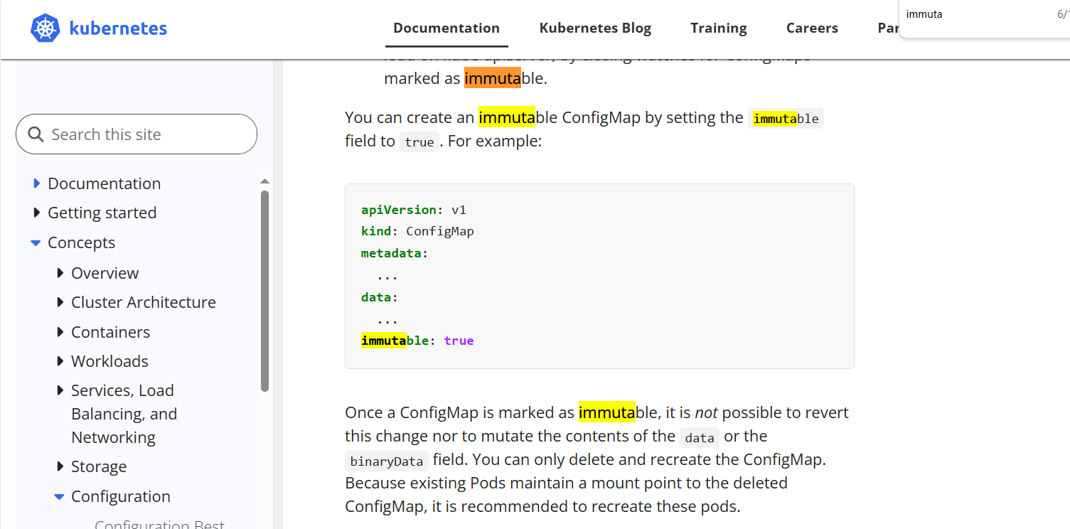
apiVersion: v1
kind: ConfigMap
metadata:
name: nginx-config
namespace: webapp
data:
nginx.conf: |
server {
listen 443 ssl;
server_name webapp.local;

ssl_certificate /etc/nginx/tls/tls.crt;
ssl_certificate_key /etc/nginx/tls/tls.key;

ssl_protocols TLSv1.2 TLSv1.3;

location / {
return 200 "Hello Secure World!";
}
}
immutable: true
Note:In exam config maps and deployment and curl command will be mentioned. Make sure you ssh to the correct cluster and perfoming for every questions, for this question if you are having any doubts you can open the deployment and check the config maps details . In below for our practice I have given every thing in the yaml , if yaml is not there you can use the kubectl edit command for the config map or get the config map details in to yaml using the kubectl get command and update and configure to the requirement.

Below is out of box for the exam this is for you information. We use the curl -k to verify -k is insecure methode why we use this even though we created the cert is because that is self signed cert not trusted or sugned by any ca. To make it trust follow below steps .

sudo cp tls.crt /usr/local/share/ca-certificates/webapp.crt
sudo update-ca-certificates

controlplane:~$ echo "127.0.0.1 webapp.local" | sudo tee -a /etc/hosts
127.0.0.1 webapp.local

controlplane:~$ curl https://webapp.local:30443 --tls-max 1.3
Hello Secure World!

Question No:21

Namespace: sound repeater
Exposing Service Echoserver-service on http://example.org/echo using service port 8080

Expose the service echo-server in the given name space Create an nginx ingress for aabove deployment and service for the host http://www.example.org/echo over port 80 curl -o /dev/null -s -w "%{http_code}\n" http://example.org/echo.

Solution:
kubectl create namespace sound-repeater

Create a deployment :
apiVersion: apps/v1
kind: Deployment
metadata:
name: echo-server
namespace: sound-repeater
spec:
replicas: 1
selector:
matchLabels:
app: echo-server
template:
metadata:
labels:
app: echo-server
spec:
containers:
- name: echo
image: hashicorp/http-echo
args:
- "-text=echo"
ports:
- containerPort: 5678

Create service to expose the container:

apiVersion: v1
kind: Service
metadata:
name: echo-server
namespace: sound-repeater
spec:
selector:
app: echo-server
ports:
- name: http
port: 8080
targetPort: 5678

Create ingress resource :
apiVersion: networking.k8s.io/v1
kind: Ingress
metadata:
name: echo-ingress
namespace: sound-repeater
annotations:
nginx.ingress.kubernetes.io/rewrite-target: /
spec:
rules:
- host: example.org
http:
paths:
- path: /echo
pathType: Prefix
backend:
service:
name: echo-server
port:
number: 8080

Update host:
sudo echo "127.0.0.1 example.org" >> /etc/hosts

Verify using below command :
curl -o /dev/null -s -w "%{http_code}\n" http://example.org/echo

Question NO:22

Kubernetes Cluster is not working . Some components are down after a cluster migration.
Trouble shoot the cluster and fix the cluster.

In exam you will not be able to run any of the kubectl command due to issue in kubernetes.
In exam issue will be in the etcd , please follow the below steps.

controlplane:~$ cd /etc/kubernetes/manifests/
controlplane:/etc/kubernetes/manifests$ ls -ltr
total 16
-rw------- 1 root root 3871 May 11 17:17 kube-apiserver.yaml
-rw------- 1 root root 3393 May 11 17:17 kube-controller-manager.yaml
-rw------- 1 root root 2534 May 11 17:17 etcd.yaml
-rw------- 1 root root 1655 May 11 17:17 kube-scheduler.yaml
controlplane:/etc/kubernetes/manifests$ vi kube-apiserver.yaml

controlplane:/etc/kubernetes/manifests$ vi kube-apiserver.yaml
apiVersion: v1
kind: Pod
metadata:
annotations:
kubeadm.kubernetes.io/kube-apiserver.advertise-address.endpoint: 172.30.1.2:6443
creationTimestamp: null
labels:
component: kube-apiserver
tier: control-plane
name: kube-apiserver
namespace: kube-system
spec:
containers:
- command:
- kube-apiserver
- --advertise-address=172.30.1.2
- --allow-privileged=true
- --authorization-mode=Node,RBAC
- --client-ca-file=/etc/kubernetes/pki/ca.crt
- --enable-admission-plugins=NodeRestriction
- --enable-bootstrap-token-auth=true
- --etcd-cafile=/etc/kubernetes/pki/etcd/ca.crt
- --etcd-certfile=/etc/kubernetes/pki/apiserver-etcd-client.crt
- --etcd-keyfile=/etc/kubernetes/pki/apiserver-etcd-client.key
- --etcd-servers=https://127.0.0.1:2379
- --kubelet-client-certificate=/etc/kubernetes/pki/apiserver-kubelet-client.crt
- --kubelet-client-key=/etc/kubernetes/pki/apiserver-kubelet-client.key

controlplane:/etc/kubernetes/manifests$ systemctl status kubelet
● kubelet.service - kubelet: The Kubernetes Node Agent
Loaded: loaded (/usr/lib/systemd/system/kubelet.service; enabled; preset: enabled)
Drop-In: /usr/lib/systemd/system/kubelet.service.d
└─10-kubeadm.conf
Active: active (running) since Mon 2025-05-12 17:04:07 UTC; 16min ago
Docs: https://kubernetes.io/docs/
Main PID: 1474 (kubelet)
Tasks: 10 (limit: 2614)
Memory: 69.1M (peak: 69.6M)
CPU: 13.816s
CGroup: /system.slice/kubelet.service
└─1474 /usr/bin/kubelet --bootstrap-kubeconfig=/etc/kubernetes/bootstrap-kubelet.conf --kubeconfig=/etc/kubernetes/kubelet.conf --c>

controlplane:/etc/kubernetes/manifests$ systemctl restart kubelet
controlplane:/etc/kubernetes/manifests$ systemctl status kubelet
● kubelet.service - kubelet: The Kubernetes Node Agent
Loaded: loaded (/usr/lib/systemd/system/kubelet.service; enabled; preset: enabled)
Drop-In: /usr/lib/systemd/system/kubelet.service.d
└─10-kubeadm.conf
Active: active (running) since Mon 2025-05-12 17:20:56 UTC; 4s ago
Docs: https://kubernetes.io/docs/
Main PID: 11455 (kubelet)
Tasks: 8 (limit: 2614)
Memory: 44.7M (peak: 44.9M)
CPU: 363ms
CGroup: /system.slice/kubelet.service

